<!DOCTYPE html>

<html lang="en">

<head>

  <meta charset="UTF-8">

  <meta name="viewport" content="width=device-width, initial-scale=1.0">

  <title>JavaScript Events</title>

  <link rel="stylesheet" href="JavaScript_Events1.css">

</head>

<body>

  <div class="section">

    <h2><b><u>Mouse Event</u></b></h2>

    <div id="mousebox" class="box" onclick="singleClick()" ondblclick="doubleClick()">Click Here!

    </div>

    <p id="Mouse_Event">Hover and Click here</p>

  </div>

  <div class="section">

    <h2><b><u>Keyboard Event</u></b></h2>

    <input type="text" id="InputKeyboard" onkeydown="handleKeyDown()"

            onkeyup="handleKeyUp()" onkeypress="handleKeyPress()" placeholder=" ">

        <p id="Keyboard_Event">Type here!</p>

  </div>

  <div class="section">

    <h2>Form Events</h2>

    <form id="demoForm" onsubmit="handleSubmit(event)">

      <label for="name-input">Name:</label>

      <input type="text" id="name-input"><br><br>

      <label for="email-input">Email:</label>

      <input type="email" id="email-input"><br><br>

      <button type="submit">Submit</button>

    </form>

    <p id="formEventResult">Form data will be displayed here.</p>

  </div>

  <div class="section">

    <h2><b><u>Drag Event</u></b></h2>

    <div class="container">

      <div id="dragBox" draggable="true" ondragstart="dragStart(event)">Drag me</div>

      <div id="dropBox" ondragover="allowDrop(event)" ondrop="drop(event)">Drop here</div>

  </div>

        <p id="Drag_Event" align="center">Drag the box and drop here !</p>

  </div>

  <div class="container">

    <video id="videoPlayer" width="600" controls>

      <source src="Video 1.mp4" type="video/mp4">

      Your browser does not support the video tag.

    </video>

    <div class="controls">

      <button id="playButton">Play</button>

      <br>

      <button id="pauseButton">Pause</button>

      <br>

      <button id="resetButton">Reset</button>

      <br>

    </div>

  </div>

  <br>

  <br>

  <img src="5.jpg" alt="Your Image" onclick="toggleBlur()">

  <br>

  <br>

  <audio controls>

        <source src="Audio 1.mp3" type="audio/mpeg">

        Your browser does not support the audio element.

    </audio>

  <script src="JavaScript_Events1.js">

  </script>

</body>

</html>

Css file

* {

    margin: 0;

    padding: 0;

    font-family: "Baskerville", serif;

    box-sizing: border-box;

    }

    body{

    background:#a7c3ab

    margin:20px

    }

    .section {

    margin-bottom: 40px;

    }

    .section h2 {

    margin-bottom: 10px;

    }

    .box {

    width: 150px;

    height: 150px;

    background-color: rgb(191, 212, 173);

    border: 1px solid #436131;

    margin-bottom: 10px;

    text-align: center;

    line-height: 150px;

    }

    .box:hover {

    background-color: #88cf66;

    }

    .container {

    display: flex;

    justify-content: center;

    align-items: center;

    gap: 50px;

    }

    #dragBox {

    width: 100px;

    height: 100px;

    background-color: #b0cf78;

    color: rgb(83, 111, 35);

    display: flex;

    justify-content: center;

    align-items: center;

    cursor: grab;

    border-radius: 5px;

    font-size: 16px;

    }

    #dropBox {

    width: 200px;

    height: 200px;

    background-color: #85b42f;

    color: rgb(83, 111, 35);

    display: flex;

    justify-content: center;

    align-items: center;

    border-radius: 10px;

    font-size: 18px;

    }

    video {

    border: 2px solid #333;

    border-radius: 4px;

    }

    .controls {

    margin-top: 10px;

    }

    button {

    padding: 10px 20px;

    font-size: 16px;

    margin: 0 5px;

    cursor: pointer;

    border: none;

    border-radius: 5px;

    background-color: #0f7230;

    color: white;

    transition: background-color 0.3s ease;

    }

    input {

      padding: 10px;

      font-size: 16px;

      border: 2px solid #ccc;

      border-radius: 5px;

      transition: border-color 0.3s ease;

    }

    .image-container {

      align: center;

    }

    .blurred {

      filter: blur(5px);

    }

    .audio{

      width: 300px;

      height: 50px;

      margin-bottom: 20px;

    }

Js file

function singleClick(){

    document.getElementById('Mouse_Event').textContent="Clicked!!!!";

    }

    function doubleClick(){

        document.getElementById('Mouse_Event').textContent="Double Clicked!!!!";

    }

    function handleKeyDown() {

        document.getElementById('Keyboard_Event').textContent = "Key Down!";

    }

    function handleKeyUp() {

        document.getElementById('Keyboard_Event').textContent = "Key Up!";

    }

    function handleSubmit(event) {

        event.preventDefault();

        const nameInput = document.getElementById('name-input');

        const emailInput = document.getElementById('email-input');

        const name = nameInput.value;

        const email = emailInput.value;

        const formEventResult = document.getElementById('formEventResult');

        formEventResult.textContent = `Name: ${name}\nEmail: ${email}`;

      }

      function allowDrop(event) {

        event.preventDefault();

    }

    function dragStart(event) {

        event.dataTransfer.setData("text", event.target.id);

        event.target.textContent = "Dragged";

    }

    function drop(event) {

        event.preventDefault();

        var data = event.dataTransfer.getData("text");

        var dragBox = document.getElementById(data);

        var dropBox = event.target;

        dropBox.appendChild(dragBox);

        dropBox.textContent = "Dropped";

    }

    const videoPlayer = document.getElementById('videoPlayer');

    const playButton = document.getElementById('playButton');

    const pauseButton = document.getElementById('pauseButton');

    const resetButton = document.getElementById('resetButton');

    playButton.addEventListener('click', function() {

      videoPlayer.play();

    });

    pauseButton.addEventListener('click', function() {

      videoPlayer.pause();

    });

    resetButton.addEventListener('click', function() {

      videoPlayer.currentTime = 0;

      videoPlayer.pause();

    });function toggleBlur() {

      const image = document.querySelector('img');

      image.classList.toggle('blurred');

  }

  const audioElement = document.getElementById("myAudio");

  function playAudio() {

      audioElement.play();

  }

  function pauseAudio() {

      audioElement.pause();

  }

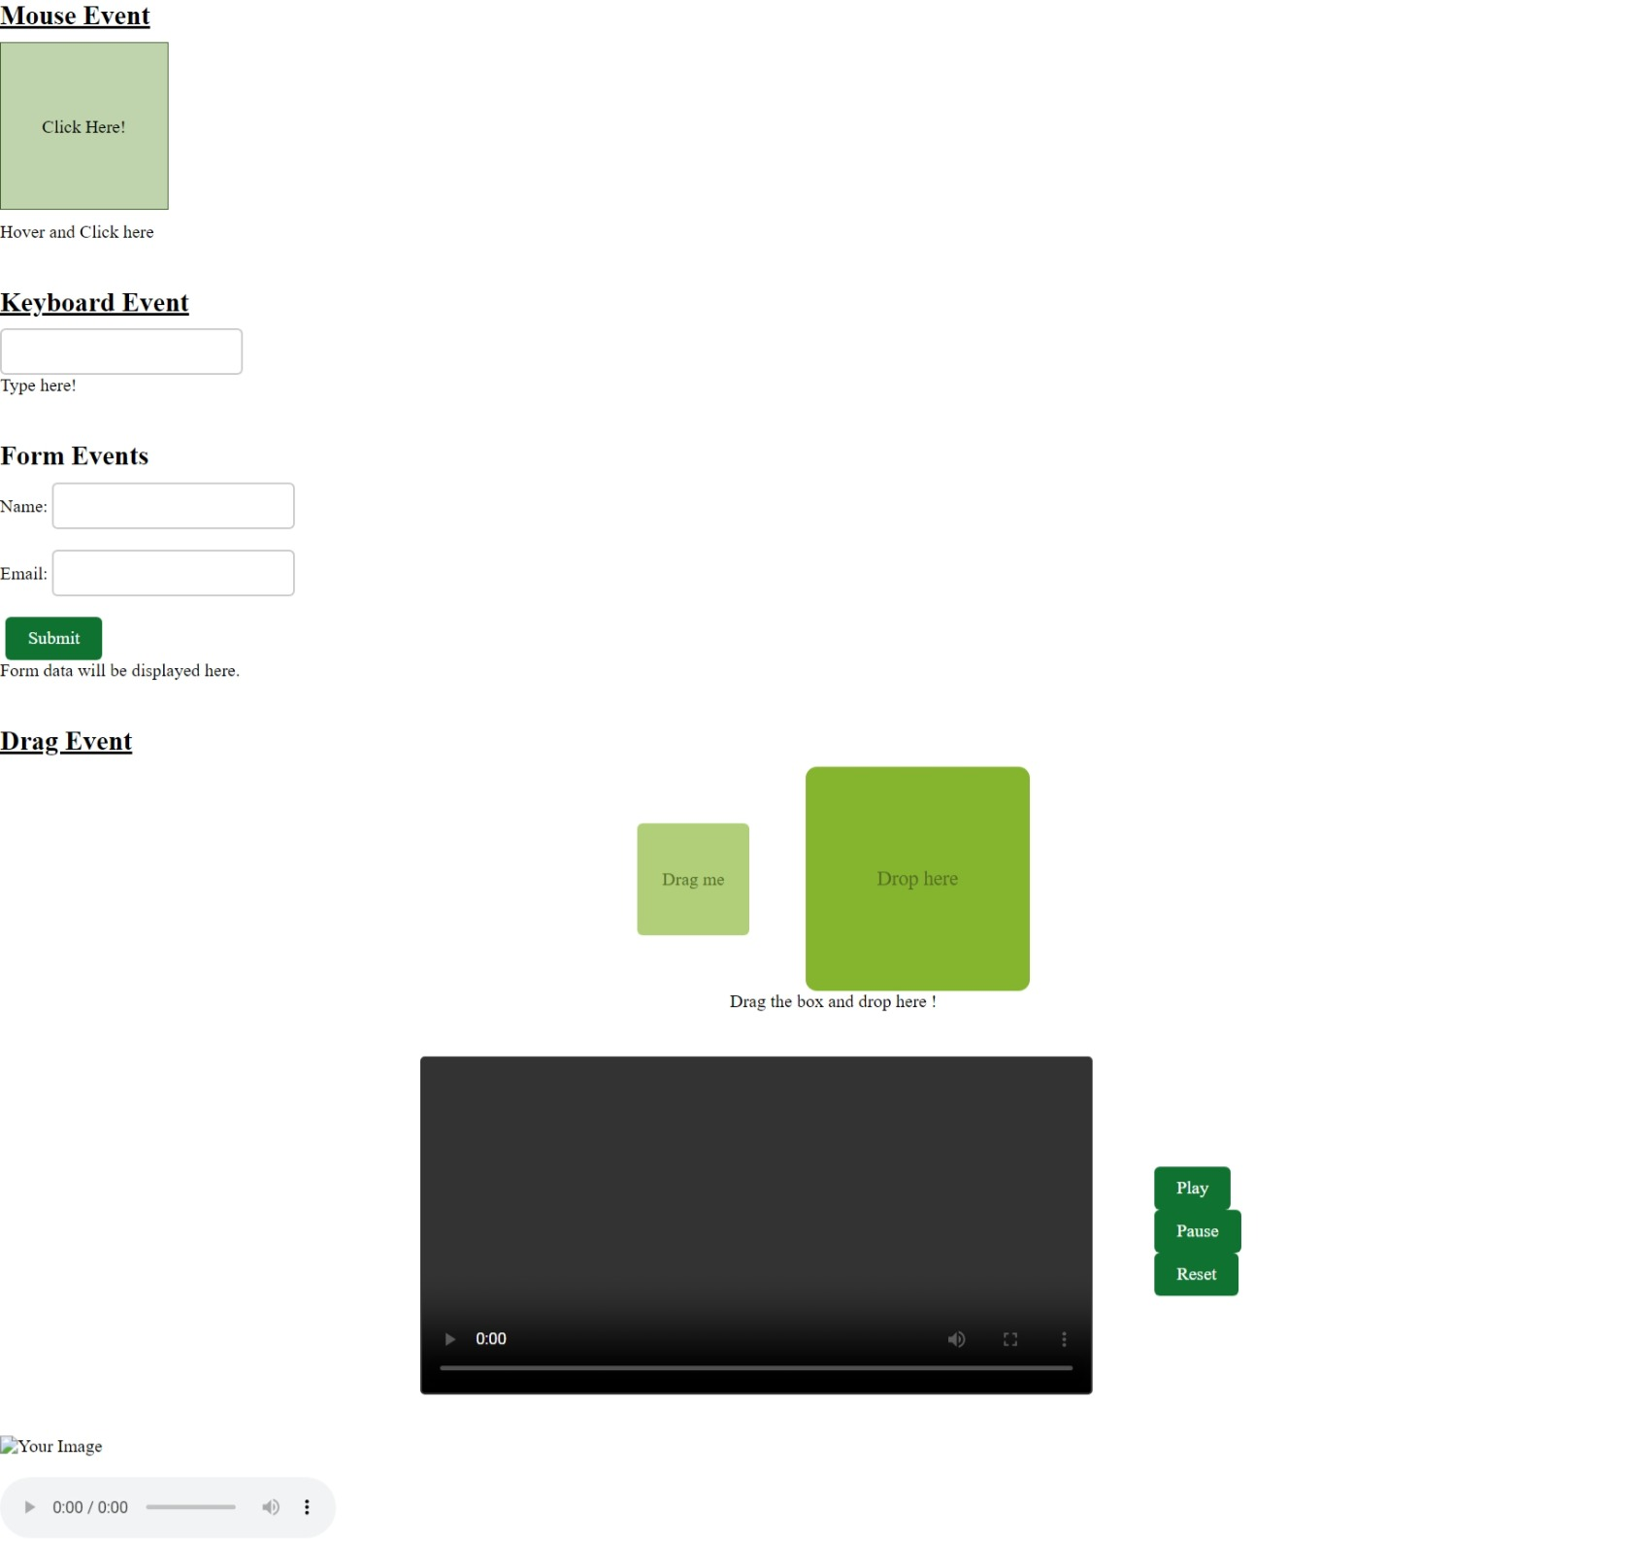Output: